**PROJECT TITLE:** Creating Blog Using WordPress Platform

Group Members (NM ID):1. 9C0BA203F3076979EAC49B4740AF62F4

2. 546CE19AA1D8A2F81034BDFC6EA2897D

3. E70175F5355957290FC46F27B1B5017A

4. E91026230FB1F48B0844B6A7EB8FFD35

**Blog Name:** The Flavor Atlas.

**Category:** Foods.

**Email:** flavoratlas@gmail.com

**WordPress Blog URL:** <https://theflavoatlas.wordpress.com/>

**Post into Social Media Website:**

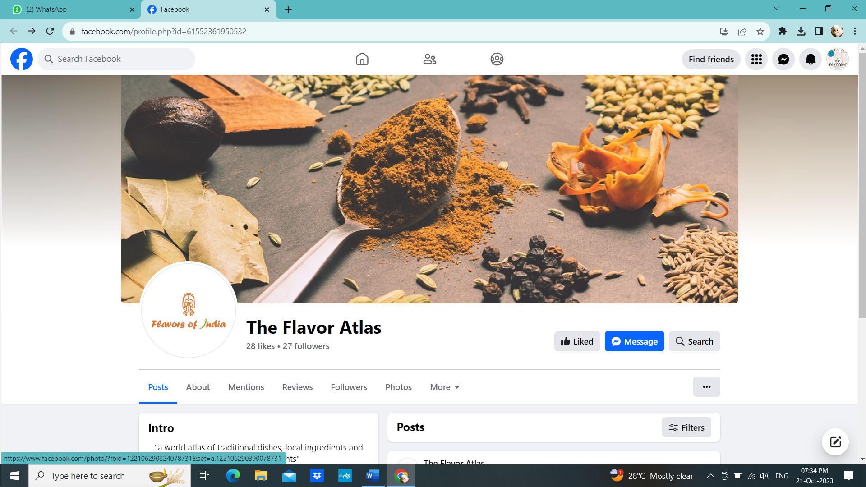

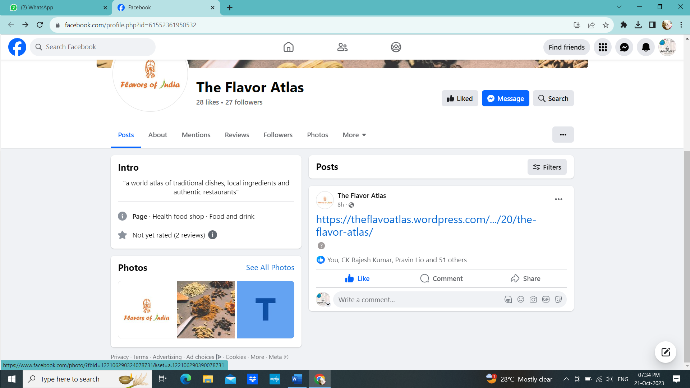

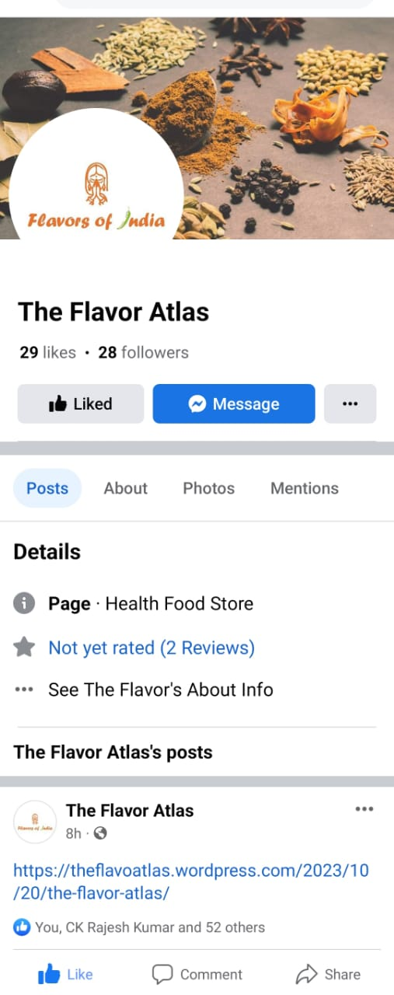

**Document:**



**Document Drive Link:** <https://drive.google.com/file/d/1mlXOEtBaWIE7vsBEQxA15F4Wbmb0TcD7/view?usp=drivesdk>

Facebook link: <https://www.facebook.com/profile.php?id=61552361950532>

**Recorded video:**

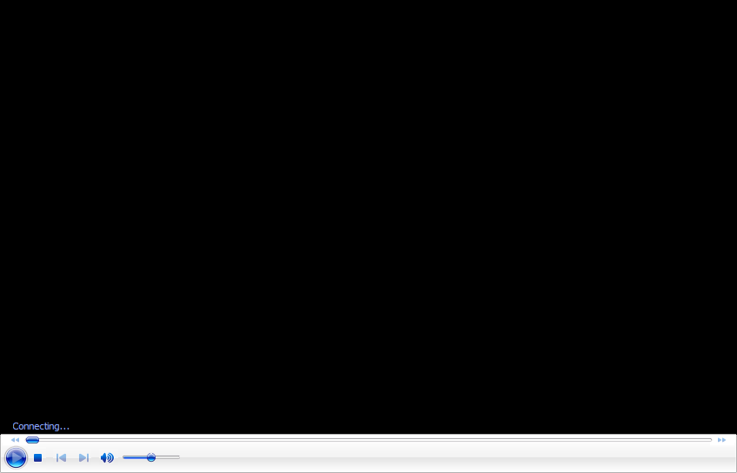

**Drive link:** <https://drive.google.com/file/d/1kbi8qti9WvMq-wBOi1-zxUx38MnFejK7/view?usp=drivesdk>